# **LAB 14**

# **Scenario 1: Configuring a firewall on a router and creating ACL**

In this project, our goal was to showcase the working of a firewall in a network and how the ACL works. Our setup was simple and easy to understand but it shows how a firewall is a powerful security tool in our digital world.

### **Problem Statement:**

A small lab in a start-up requires a network setup. It has 3 permanent employees and 3 freelancers. The CEO thinks that it's best to keep the freelancers blocked from talking to the internal employees. So he wants to configure the firewall on his network.

### **Objective**

To be able to segment 2 networks and block unwanted communication among the network users.

### **Key Requirements**

1. 2 networks with some PCs
2. A router that can act as a firewall
3. ACL configuration

### **Proposed Solution**

The following steps were undertaken to address the problem:

1. **Hardware Setup**:
   1. Set up 2 networks, connected PCs and switches
   2. Connected the networks with a router
   3. Wired everything with appropriate wires
   4. Assigned IP addresses
2. **Router Configuration**:
   1. Configured the router as a gateway
   2. Configured ACL rules to make the router act as a firewall
3. **Switch Configuration**:
   1. Connected switch to PCs
   2. Connected it to router
4. **Verification**:
   1. Ensured connectivity by pinging IPs on the other network.
   2. Made sure that blocked IPs were unable to receive or send any pings.

### **Outcome**

We were able to successfully configure a firewall and segment the communication.

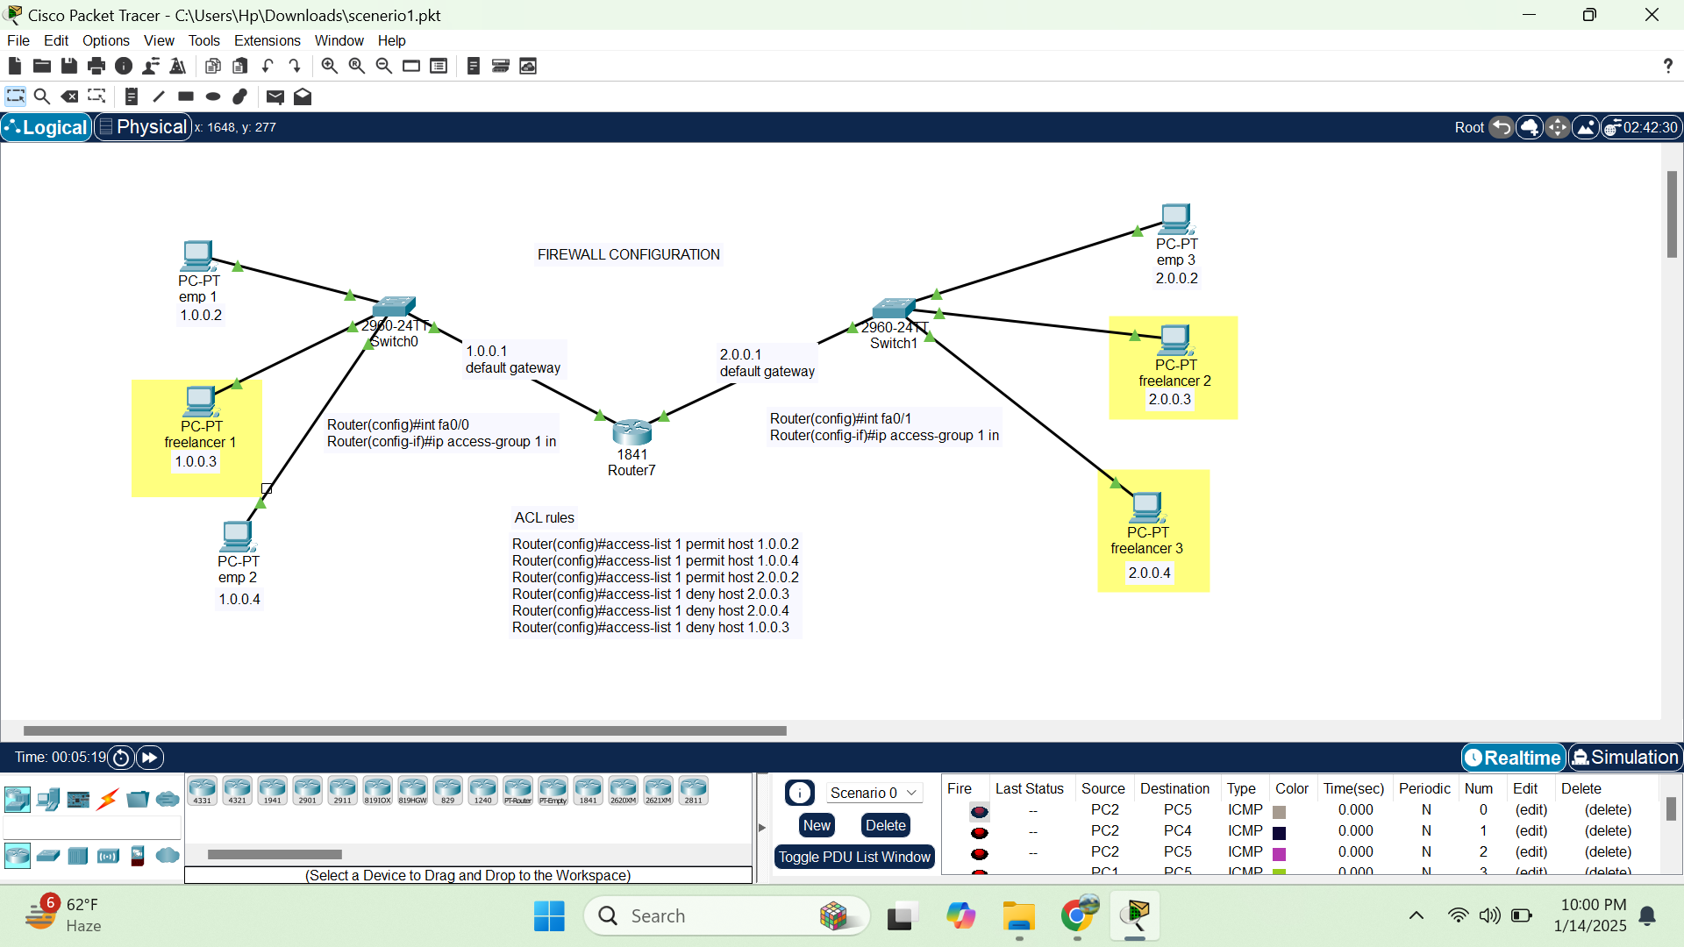

# **Scenario 2: Integrating a Cisco Router with a DSL Modem for ISP Connectivity**

In this project, we aim to configure a Cisco router to establish a reliable internet connection through a DSL modem. This setup is designed to enable internal devices in a network to access the internet by routing traffic through the configured modem and router.

### **Problem Statement**

A small office network requires a reliable internet connection to facilitate external communication and web-based operations. The office has a DSL modem provided by the Internet Service Provider (ISP) and a Cisco router. The challenge is to configure the router and modem to work together seamlessly for internet connectivity.

### **Objective**

To establish an end-to-end connection between the internal network and the ISP by configuring the Cisco router with the DSL modem, ensuring devices in the network can access the internet securely and efficiently.

### 

### **Key Requirements**

1. A functional DSL modem connected to the ISP.
2. A Cisco router with console access for configuration.
3. Ethernet cables for connectivity.
4. A computer with terminal emulation software (e.g., PuTTY) for CLI access.

### **Proposed Solution**

The following steps were undertaken to address the problem:

1. **Hardware Setup**:  
   * Connected the DSL modem to the ISP’s telephone line.
   * Linked the modem to the router’s WAN interface using an Ethernet cable.
   * Connected a PC to the router’s console port for configuration.
2. **Router Configuration**:  
   * Assigned IP addresses to the router's interfaces.
   * Configured a default route to forward traffic to the ISP's gateway.
   * Enabled Network Address Translation (NAT) to allow multiple devices on the internal network to access the internet.
3. **Verification**:  
   * Ensured connectivity by pinging external IPs.
   * Saved the router’s configuration for persistent operation.

### **Outcome**

The project successfully established internet connectivity through the integration of the Cisco router and DSL modem. All internal devices could access the internet efficiently, and the router ensured proper traffic routing and address translation.

